Romanian NMA Training Placement Scheme
Second semestrial scientific report, October 2025

Claudiu Adam (EUMETSAT Placement Scheme Trainee, NMA),
Eugen Mihuleț (NMA)

ABSTRACT
This work presents the adaptation of the COALITION-4 deep learning model for operational nowcasting at the Romanian National Meteorological Administration, integrating multi-source data including S-band dual-polarimetric radar, MSG SEVIRI satellite products, LINET lightning observations, and ICON numerical weather predictions, and digital elevation model of Romania. A knowledge distillation approach successfully transferred learned meteorological patterns from the Swiss-trained model to a Romanian-adapted model, while a novel Grad-CAM (Gradient-weighted Class Activation Mapping) and Xi correlation methodology identified optimal input features by confirming DEM data as detrimental and NWP products as marginally contributive. The distilled model demonstrates realistic nowcasting capabilities for radar reflectivity across diverse convective scenarios, with future work focused on MSG-to-MTG transition, physics-based module integration, and operational deployment through NMA infrastructure services.

Introduction
Over the past year, work has been conducted to adapt the COALITION-4 nowcasting system to the Romanian context through systematic integration of national data sources, model architecture reconfiguration, and validation against convective scenarios from generated datasets. The system utilizes a recurrent-convolutional encoder-decoder architecture operating on the Stereo70 projection of Romania with data from S-band dual-polarimetric radar network, MSG SEVIRI rapid-scan satellite products (5-minute resolution), LINET lightning detection, ICON numerical model outputs, and digital elevation data. During the last six months, significant advances were achieved through implementation of DBSCAN-based convective cell identification with consistent 256×256 to 32×32 pixel patch extraction, deployment of a three-component knowledge distillation strategy (hard, soft, and feature-level losses) to transfer Swiss model expertise to Romanian data, and comprehensive feature importance analysis using combined Grad-CAM and Xi correlation coefficients. This analysis validated MeteoSwiss findings that DEM data degrades model performance while additionally revealing that NWP products contribute marginally (ξ ≈ 0.52) relative to their computational cost, leading to an
optimized feature set comprising radar, satellite, lightning, and NWCSAF products. The distilled model predicts radar reflectivity with similar spatial structure and temporal decay, relative to ground truth values, despite training on only 288 samples, demonstrating good generalization across convective cells for up to 30-minutes lead time, considering the small training dataset.

Development process and model guideline
The first step was identifying the stereographic projection of Romania. We then identified extreme cardinal points and plotted the rectangle that serves as the extended area of interest of model domain. From the defined study area, we then extracted patches of 256x256 pixel coverage – one pixel representing roughly 1 km. The extraction process was handled automatically by DBSCAN unsupervised learning clustering algorithm, which identified rainfall clusters exceeding 10 mm/h precipitation hourly rate (65536 km²) patches through careful tuning of the parameters, such as epsilon parameter – maximum distance between two points to be considered neighbors (in pixels), minimum samples – minimum number of points required to form a region, or the maximum number of clusters to be considered after DBSCAN found all valid cluster. This approach was implemented to have more control over the target patch extraction process, instead of having a static standard process. This gives the opportunity for further improvements with later iterations of this method extracting patches with higher accuracy and precision, for larger area extents, maintaining the dynamical interpretation of the solution. After the extraction of the larger patches, each patch was split into smaller 32x32 pixels.
The algorithms for dataset creation were altered to match the new patch extraction approach. The dataset consists of 3 different subsets, test, train, and validation sets, each with their own block of timestamps. For example, considering our 288 samples of data with 5-minute temporal resolution, across a 24h period covering two days (13th and 14th of June 2024), test set was defined from 03:00 UTC to 06:00 UTC, train set from 06:05 UTC to 20:00 UTC, and validation from 20:05 UTC to 03:00 UTC the next day. Within each time block, the samples were randomly shuffled. The limited sample training was done due to two reasons: faster training times and experimentation, and product creation. The first reason is straightforward and allowed us to test different algorithms for data resampling or different plotting functions, for example. The second reason refers to the fact that the data preprocessing pipeline assumes one important prerequisite, and that is temporal resolution of 5-minutes for all data products, defined over the area of interest. Each radar from the seven radar network of Romania, creates independent products for that specific region (less than 200 km range). This was a limitation because, even though NMA provided the necessary radar products, they had to be aggregated into a national mosaic to meet the requirements of training COALITION-4 and had to be created specifically for this project. Another limitation was that we needed all products to have a 5-minute temporal resolution, including NWP data generated by ICON. In the operational context, data is created at 1-hour timestamps and in order to match the requirements of the model, the NWP department had to rerun ICON with 5-minute timestamp. COALITION-4 requires some of the products to be on a 64x64 pixels and others on 256x256 pixels.
Patch extraction, data preprocessing, dataset creation, and model training and validation generate the results by running two different scripts in order to make the codebase modular, in case other member states decide to adapt this model to their operational needs. As the general architecture of COALITION-4 is dependent on dataset structure, dynamically defining it, in most cases, as it was the case with our datasets, the created architecture based on the data provided will not create the same network and thus the model will not be able to get initialized using its learned weights from original Switzerland learned data. We modified the original code for dataset creation to match our new patch extraction approach and the direct fine-tuning became obsolete. To bypass the problem of mismatched network architectures and to still be able to train the model with some of the knowledge from pre-trained COALITION-4, we employed a two-stage learning process: knowledge distillation and fine-tuning. The first stage implements knowledge distillation, a technique that, as the name suggests, it transfers some of the learned knowledge or features from “teacher” model, in this case pre-trained model with loaded weights using the original dataset creation code and Switzerland data, to the “student” model which is created using the Romanian data with randomly initialized weights. The training is done on the full training dataset of Romanian data and on a small subset from the training set of Switzerland.
The second stage implies “student” model fine-tuning on the full dataset. During this stage, the evolution of convective cells in terms of positioning and intensity appear to yield good results up to 30-minutes leadtime. Past that leadtime mark, the intensity starts to fade away on the regions that are no longer affected by the cell, but the model starts to lose track of the positioning and shape of the convective cell. At the same time, we noticed a steep loss in sharpness from the third timestamp onwards (see Distilled model performance chapter for results). This behavior is also usually correlated with training data-driven models, as it is a limitation of neural networks, especially convolutional-based neural networks. By training with a bigger and highly curated dataset, the performance of the model will significantly improve and most of the issues will be diminished.
We conducted an analysis on the pre-trained model using a novel approach, integrating Grad-CAM algorithm with Xi coefficient of correlation. The method identifies essential input variables through direct analysis of spatial attention patterns taken from the trained layers of the neural network. This technique compares spatial regions at the input level with those in the final predictions, using the Xi coefficient to quantify the non-parametric correlation between these attention maps (see Layer-specific feature importance chapter for results).

Data sources and preprocessing
COALITION-4 [1] has been adapted according to the geographical and climatic specifics of Romania. The system uses a recurrent-convolutional architecture with an encoder-decoder structure for multi-hazard nowcasting predictions (lightning, reflectivity, precipitation). The data projection is the stereographic projection specific to Romania (Stereo 70, Dealul Piscului, EPSG:31700) and the extraction polygon has been modeled to include ​​values near the borders. Data from the national network of meteorological radars, satellite products, lightning phenomena from national network, data generated by the ICON numerical model at a resolution of 2.8 km and data from the digital elevation model of Romania (spatial resolution of 1 km, obtained from NOAA) were integrated. The identification of convection cells was performed with the DBSCAN clustering algorithm and by extracting patches of 256×256 pixels, subsequently standardized to patches of 32×32 pixels.

Convective cell identification and patch extraction
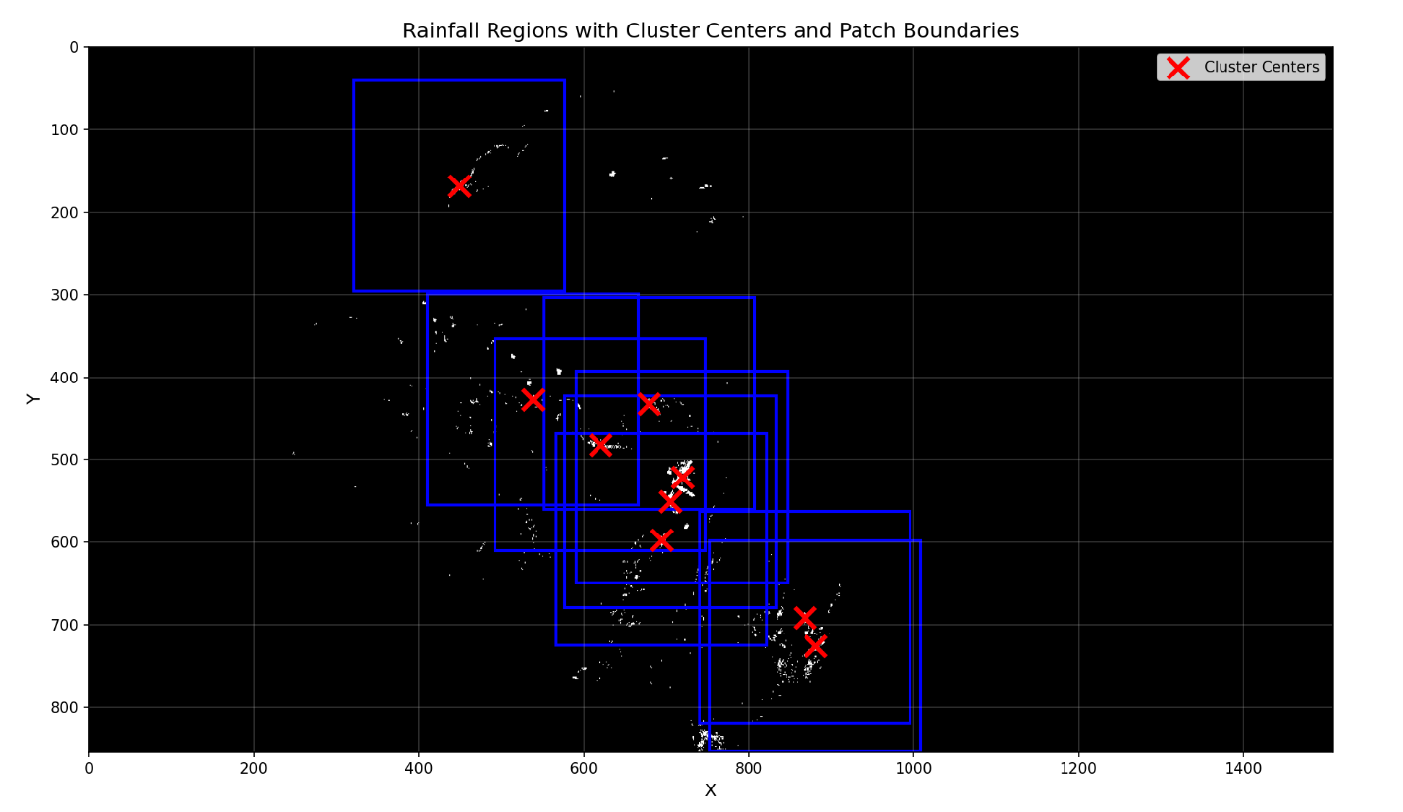
Figure 1. Spatial clustering of rainfall regions using DBSCAN algorithm

The figure shows a black background representing the Romanian radar domain with white scattered pixels indicating precipitation regions. Red markers denote cluster centers identified by the DBSCAN algorithm, while blue squares represent 256×256 extraction boundaries around each cluster. This spatial clustering approach ensures that the model focuses on convective features rather than processing the entire domain uniformly.
Convective cells were identified using the DBSCAN clustering algorithm [5] applied to RZC, then for all products, the same patches were extracted based on the initial results of DBSCAN. For each identified cluster, 256×256 pixel patches were extracted, centered on the cluster centroid. These patches were subsequently downsampled to 32×32 pixels. The proposed approach was implemented to generate a consistent patch dataset across all products, and at the same time, to have a better control over the patch extraction process.

Model training and fine-tuning
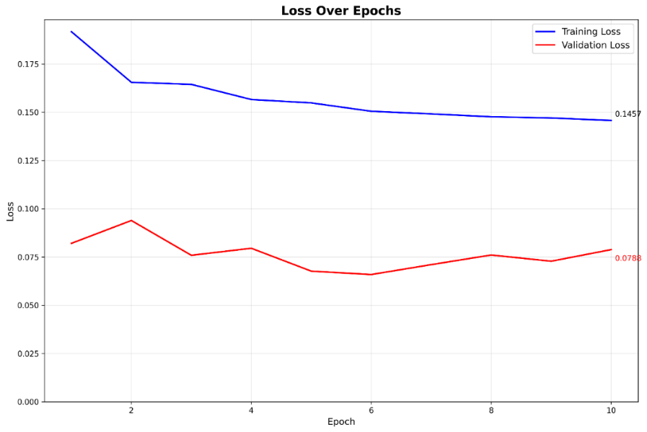
Figure 3. Training and validation loss curves over fine-tuning epochs
The loss evolution plot displays training (blue line) and validation (red line) losses over 10 epochs. Training loss decreases monotonically from 0.195 to 0.145, indicating successful model optimization. The validation loss shows more variability (ranging between 0.065 and 0.095), with notable spikes at epochs 2 and 8. This instability is attributed to the small fine-tuning dataset, which provides limited statistical coverage of meteorological variability. Despite fluctuations, validation loss remains consistently lower than training loss, suggesting the model generalizes reasonably well without overfitting.
The fine-tuning process adapted the distilled model to Romanian convective patterns using:
- Adam optimizer
- Weighted focal loss
- Learning rate = 1e-5
- Batch size = 8 (limited by GPU memory for 32×32 patches with multiple channels)
- Fine-tuning epochs = 10
- Random horizontal/vertical flips, transpose for data augmentation

Grad-CAM and Xi coefficient of correlation methodology

To validate input feature relevance and optimize computational efficiency, we implemented a novel feature selection approach combining Grad-CAM [2] with the Xi coefficient of correlation [3].
Grad-CAM generates visual explanations for deep learning model decisions by computing gradient-weighted activation maps:

L_Grad-CAM = ReLU(∑_k α_k × A_k), where

- A_k - Activation maps from convolutional layer k
- α_k - Importance weights computed as α_k = (1/Z) × ∑_i ∑_j (∂y/∂A_k)
- Z - Normalization factor
- y - Model output for target class

In our implementation, Grad-CAM was applied to both the initial convolutional layers processing concatenated input features and the final convolutional layer generating predictions at different lead times.
Xi (ξ) coefficient [3] of correlation measures nonlinear dependence between variables:

ξ(X,Y) = 1 - (n × ∑_i (r_i - r̂_i)²) / (2 × ∑_i r_i²), where

- r_i - Ranks of residuals when regressing Y on X
- r̂_i - Ranks of residuals when regressing X on Y
- n - Sample size
Xi ranges from 0 (independence) to 1 (complete dependence) and captures nonparametric relationships without assuming linearity.

For each input variable:
- Generate Grad-CAM activation maps for 4 sample batches
- Compute Grad-CAM maps for each of the 12 prediction horizons (from 5 to 60 minutes)
- Calculate ξ correlation between input-layer and output-layer activation patterns
- Aggregate results across multiple samples and lead times
- Rank features by mean ξ correlation
Features with ξ < 0.52 threshold determined empirically and validated against SHAP (SHapley Additive exPlanations) values from MeteoSwiss are candidates for removal, balancing prediction accuracy with computational efficiency.

Layer-specific feature importance

The Grad-CAM and Xi analysis was performed on the four residual block of the network, revealing hierarchical feature utilization.

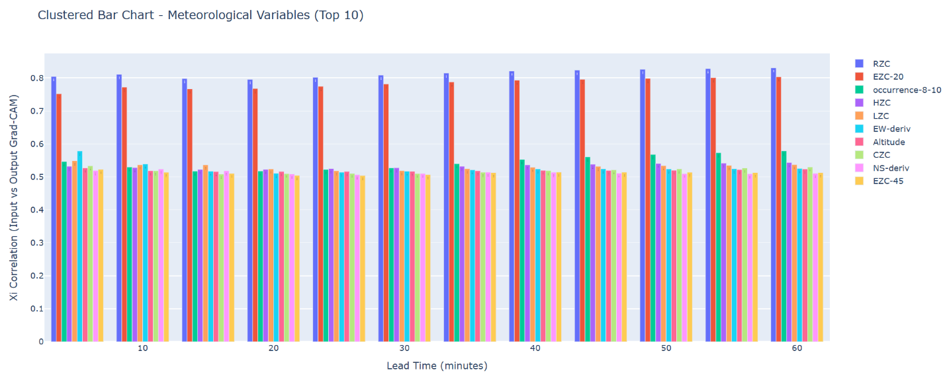
Figure 4. Feature importance at ResBlock 1

The first residual block results show the top 10 meteorological variables by Xi correlation at the first residual block across lead times from 5 to 60 minutes (x-axis). The y-axis represents Xi correlation strength (0-0.85). RZC (radar reflectivity) and EZC-20 (20 dBZ echo top) show the highest importance (~0.80-0.82), followed by IR-derived products (~0.52-0.58). This indicates that network layers rely primarily on radar and satellite observations to identify convective structures compared to the other layers analyzed that integrate the rest of the products.

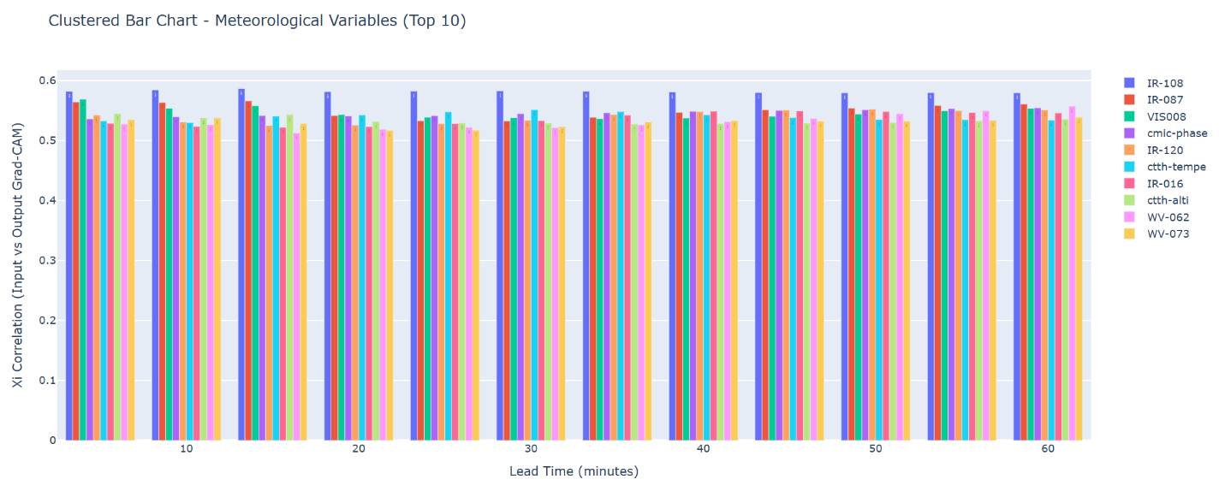
Figure 5. Feature importance at ResBlock 2
At the second residual block, the importance distribution becomes more diverse. IR-108 and IR-087 (infrared window channels) gain prominence (~0.58), approaching radar product importance. VIS008 (visible channel) and various radar products (occurrence-8-10, cmic-phase) show comparable correlations (~0.52-0.57), suggesting the model begins integrating multi-source information for convective pattern recognition.
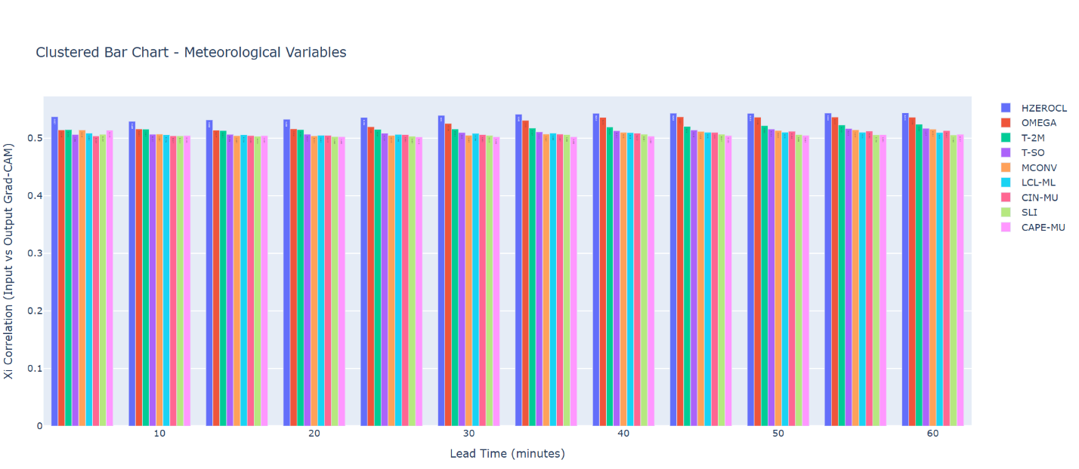
Figure 6. Feature importance at ResBlock 3

The third residual block shows HZEROCL (freezing level height), OMEGA (vertical velocity), and thermodynamic parameters gaining importance (~0.52-0.54). This reflects the model's progression from pattern recognition to physical process understanding, incorporating atmospheric stability and dynamics alongside observational data.

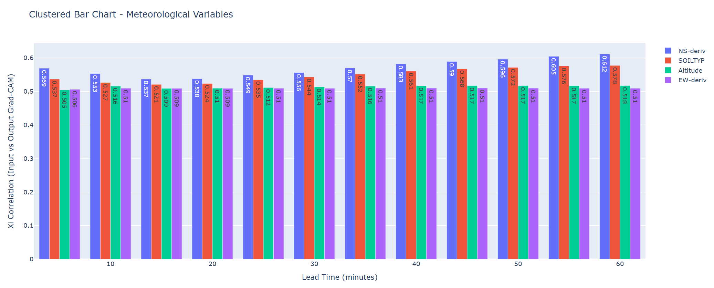
Figure 7. Feature importance at ResBlock 4

At the fourth analyzed layer, NS-derivative (north-south wind derivative), SOILTYP (soil classification), and Altitude show notable correlations (~0.52-0.60), indicating the model considers environmental factors and terrain influences when generating final predictions. This aligns with physical understanding that convective evolution is modulated by boundary layer processes and topography.

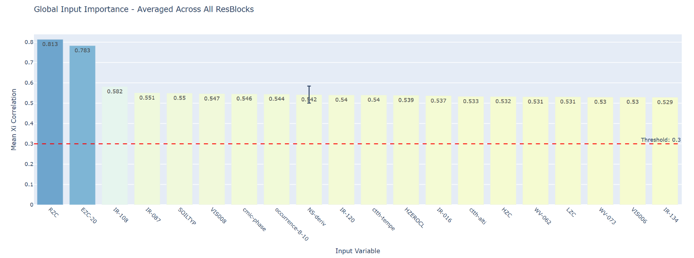
Figure 8. Globally averaged feature importance across all ResBlocks

This global ranking aggregates Xi correlations across all four residual blocks. The top 20 features are displayed, with RZC achieving ξ = 0.813 and EZC-20 reaching ξ = 0.783, far exceeding other variables. A threshold line at ξ = 0.30 indicates the minimum correlation for operational relevance. After gathering the analysis results, we concluded that:
- All top variables exceed ξ = 0.53
- Radar products (RZC, EZC-20, IR-derived products) dominate
- NWP outputs (CAPE-MU, CIN-MU, and other numerical model products) have ξ ≈ 0.52

Key findings from feature analysis

Our Grad-CAM and Xi approach [2, 3] confirmed that DEM (Digital Elevation Model) data is detrimental to model training, corroborating MeteoSwiss's SHAP-based analysis [6]. The Romanian topography's strong orographic forcing patterns may introduce overfitting when included in training.
While MeteoSwiss identified DEM as problematic, our analysis additionally revealed that NWP (Numerical Weather Prediction) products, though having measurable importance (ξ ≈ 0.52), contribute marginally compared to direct observations. Given their computational cost and latency in operational systems, NWP products are candidates for exclusion in resource-constrained deployments.
For operational Romanian nowcasting, the essential input configuration includes radar products, lightning occurrence rate, satellite data, and NWCSAF products. This reduced feature set maintains prediction quality while significantly decreasing data ingestion and preprocessing overhead.

Pre-trained COALITION-4 performance
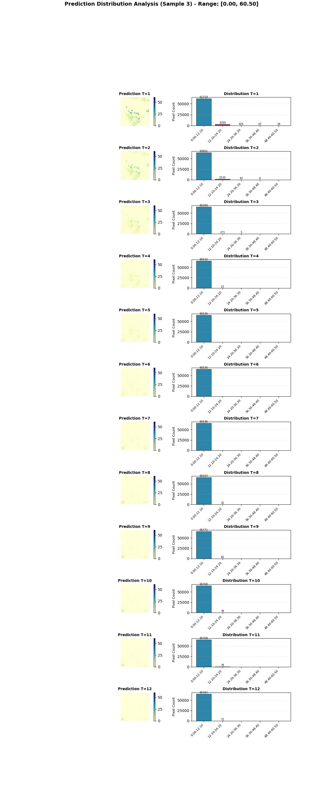
Figure 9. Reflectivity prediction (pre-trained COALITION-4)

The predictions from the above analysis represents a weak convection:
- Predominantly low-reflectivity fields across all timesteps
- Very few pixels in elevated reflectivity categories
The model predicts minimal convective development with little to no deviation across timestamps of the convective cell. This indicates that a data-driven solution, such as COALITION-4 trained on all available products, is insufficient for accurate operational analysis and other enhancements need to be considered.

Distilled model performance

The following results showcase the distilled, fine-tuned model trained on radar, satellite, NWCSAF, and lightning data (excluding NWP and DEM products) for predicting radar reflectivity (BZC).
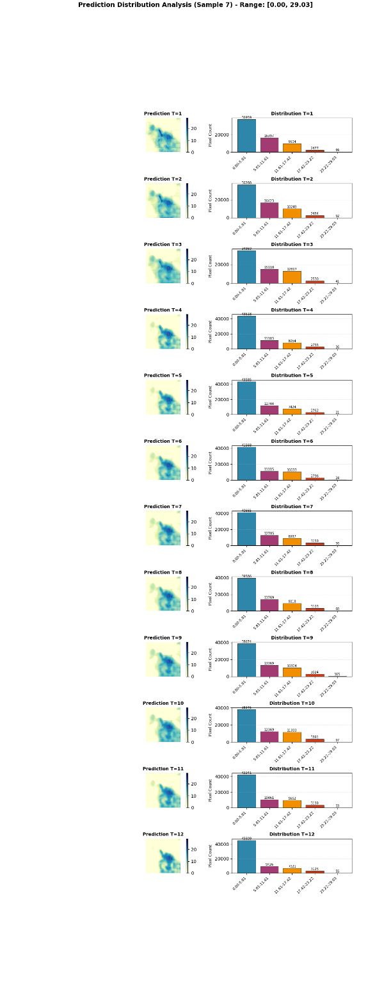

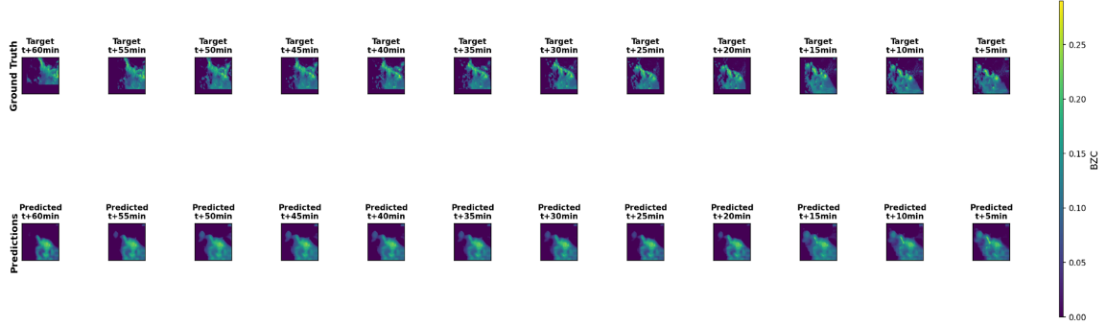

Figure 10. Reflectivity prediction sequence on a training dataset sample – ground truth compared to predicted for each timestamp

The train set example displays 12 future timesteps with prediction maps and frequency distributions, compared to the ground truth values. The spatial predictions show:
- Consistent core location tracking across lead times
- Intensity decay in later timesteps (T+10 to T+12)
The model predicts both the spatial structure and intensity evolution of this convective cell, with the distribution shift toward lower values at longer lead times.
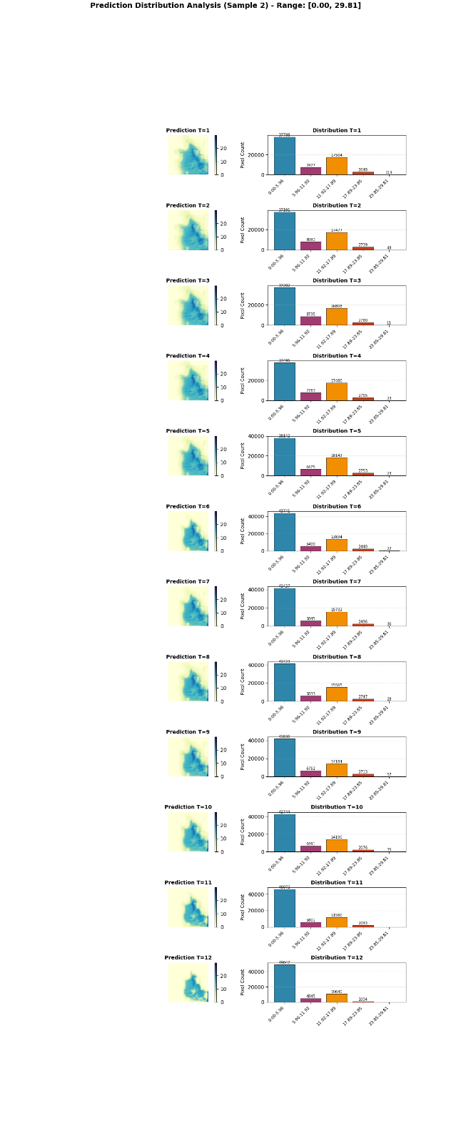

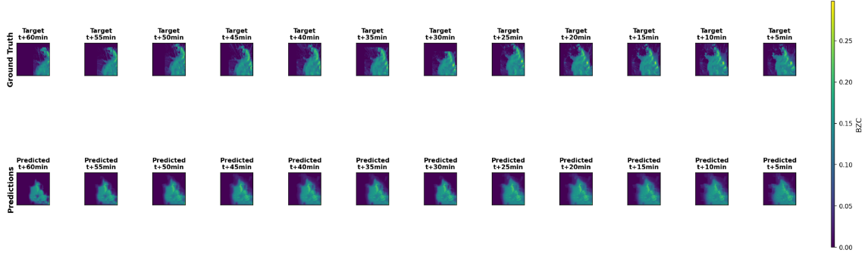

Figure 11. Reflectivity prediction sequence on a test dataset sample – ground truth compared to predicted for each timestamp

The validation sample shows different convective characteristics:
- More diffuse reflectivity patterns compared to train sample
- Multiple convective cores visible (T+1 to T+6)
The model's ability to handle diverse convective morphologies (from isolated intense cells to broader stratiform regions) demonstrates successful generalization despite the small fine-tuning dataset.

Knowledge distillation strategy

A knowledge distillation approach [4] was implemented to transfer learned meteorological patterns from the original Swiss-trained model (teacher) to Romanian-adapted model (student), due to the difficulties encountered while creating the architecture and datasets. The total loss combines three components:

L_total = α × L_hard + β × L_soft + γ × L_feature

The components are defined as follows:
- L_hard = -∑ y_true × log(y_pred), standard cross-entropy loss against ground truth labels

- L_soft = KL(softmax(z_teacher/T) || softmax(z_student/T)) × T², Kullback-Leibler divergence between teacher and student logits at temperature T

- L_feature = MSE(f_teacher, f_student), feature-level distillation between teacher and student models

The temperature parameter T softens the probability distributions, revealing more information about the teacher's learned patterns. The weighting coefficients (α, β, γ) balance the influence of each loss component.

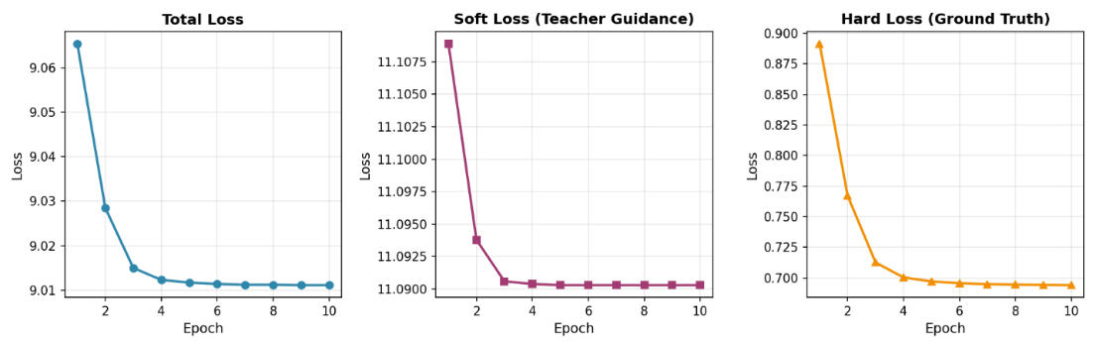
Figure 2. Three-panel training curves showing distillation process

This figure contains three panels showing the evolution of different loss components during knowledge distillation training over 10 epochs:
- Left panel - total loss combining all components, decreasing from ~9.06 to ~9.01
- Middle panel - soft loss decreasing from ~11.11 to ~11.09
- Right panel - hard loss decreasing sharply from ~0.89 to ~0.70
The rapid decrease in hard loss indicates effective learning of ground truth patterns, while the more gradual soft loss decrease shows stable knowledge transfer from the teacher model. The small dataset size of 288 samples is reflected in the relatively high absolute loss values compared to typical large-scale training.

Limitations and challenges
The system faces several challenges that limit its operational effectiveness. Lightning predictions rely on a fixed 0.9 probability threshold that may not optimize across all situations, and adaptive thresholding based on recent climatology or user-specific risk tolerance would improve operational utility. While 60-minute nowcasts offer operational value, the effective scale in most cases extends up to 30 minutes due to the loss in reliability of the predictions. A hybrid solution will be tested and validated in the future, combining nowcasting data-driven models with physics-based solutions could extend the useful forecast range beyond current limitations.

Next steps
The transition from MSG to MTG satellite platforms will be evaluated through parallel training pipelines comparing MSG SEVIRI and MTG FCI performance. MTG's superior spatial and temporal resolution and spectral capabilities are expected to improve convective initiation detection and intensity prediction. The objective is to quantify these operational advantages through comparative analysis of prediction skill, lead time accuracy, and computational requirements.

MTG requires dedicated integration strategies, including FCI's new channels, the Lightning Imager for continuous optical lightning detection, and enhanced RGB composites for identifying convective overshooting tops and storm severity indicators. Integrating these products will require extending model input channels and potentially modifying the architecture to handle increased data dimensionality.

Recognizing the limitations of purely data-driven approaches, the development of a physics-based nowcasting component aims to ensure predictions remain grounded in fundamental atmospheric principles. Pure deep learning models may struggle with unprecedented weather scenarios that fall outside the training distribution, thus we will explore physics-based constraints essential for maintaining prediction reliability, so that the system can better quantify uncertainty while providing improved performance for rare events, enhanced physical interpretability, and graceful degradation when input data quality is compromised.

Operational integration represents the culmination of research efforts, requiring deployment into NMA's operational infrastructure for real-time nowcasting alongside with the documentation for broader European access. Local deployment involves integration with existing data pipelines including radar processors, satellite reception systems, and the lightning network, complemented by real-time quality control procedures, automated product generation and dissemination to forecasters, and monitoring systems for detecting model failures or degraded performance.

References
[1] Leinonen, J., Hamann, U., Sideris, I. v., & Germann, U. (2022). Thunderstorm nowcasting with deep learning: a multi-hazard data fusion model. https://doi.org/10.1029/2022GL101626

[2] Selvaraju, R. R., Cogswell, M., Das, A., Vedantam, R., Parikh, D., & Batra, D. (2019). Grad-CAM: Visual Explanations from Deep Networks via Gradient-based Localization. https://doi.org/10.1007/s11263-019-01228-7

[3] Chatterjee, S. (2020). A new coefficient of correlation. http://arxiv.org/abs/1909.10140

[4] Hinton, G., Vinyals, O., & Dean, J. (2015). Distilling the Knowledge in a Neural Network. http://arxiv.org/abs/1503.02531

[5] Ester, M., Kriegel, H.-P., Sander, J., & Xu, X. (1996). A Density-Based Algorithm for Discovering Clusters in Large Spatial Databases with Noise. Accessed October 20, 2025, www.aaai.org.

[6] Lundberg, S., & Lee, S.-I. (2017). A Unified Approach to Interpreting Model Predictions. http://arxiv.org/abs/1705.07874

